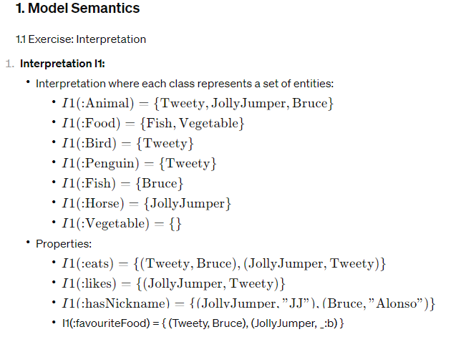

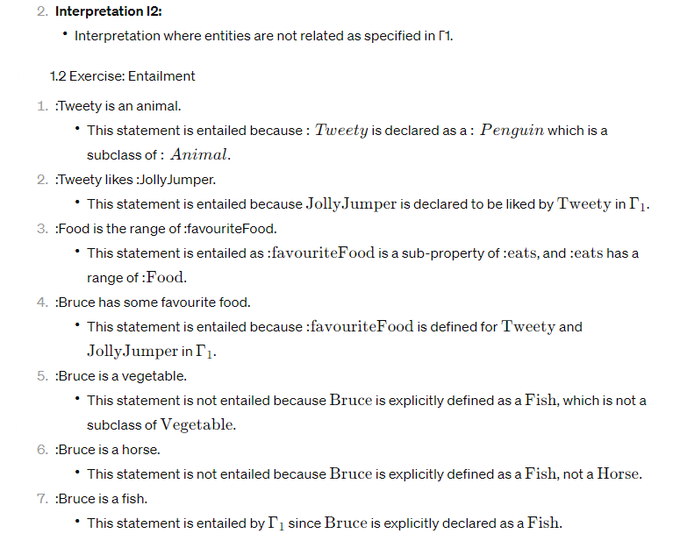

**2. Semantic web and reasoning**

**1.** Closed World Assumption vs. Open World Assumption:

**•** The closed world assumption assumes that if a fact is not known to be true, it is false. Conversely, the open world assumption states that if a fact is not known to be false, it may be true. The semantic web primarily operates under the open world assumption, as it allows for incomplete knowledge and supports incremental updates without requiring reevaluation of existing knowledge.

**2.** Unique Name Assumption vs. Non-Unique Name Assumption:

**•** The unique name assumption assumes that each name refers to a unique entity, while the non-unique name assumption allows the possibility of different entities having the same name. The semantic web operates under the unique name assumption to ensure clarity and consistency in identifying entities.

**3.** Forward Rule Chaining vs. Backwards Rule Chaining:

**•** Forward rule chaining involves applying rules to infer new information from known facts, proceeding from premises to conclusions. Backwards rule chaining involves starting with a goal and recursively applying rules to determine if the goal can be satisfied based on known facts. Forward chaining is often used in data-driven systems like the semantic web to derive conclusions from available data.

**4.** Soundness of RDFS Entailment Rules:

**•** Soundness in the context of RDFS entailment rules means that if the rules infer a statement from a set of RDF(S) assertions, then that statement is true in all interpretations that satisfy the RDF(S) semantics. In other words, the entailment rules do not produce false positives.

**5.** Incompleteness of RDFS Entailment Rules:

**•** Incompleteness implies that there may be true statements within the RDF(S) framework that cannot be derived using the entailment rules. This means the entailment rules may not capture all possible logical consequences of the RDF(S) assertions. It leaves room for extensions or additional rules to capture more entailments.

**3. RDF(S) formal semantics**

3.1 Exercise

The primary difference between the semantics presented in the Foundations of Semantic Web Technology (FSWT) and those given in the lectures may lie in the level of detail and the approach to presenting the material. Lectures might emphasize certain aspects or provide alternative perspectives on understanding RDF(S) semantics, but fundamentally, both sources should align on the core principles and definitions.